Predators

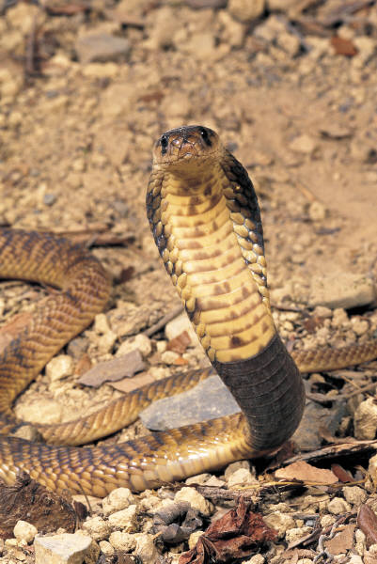
predator

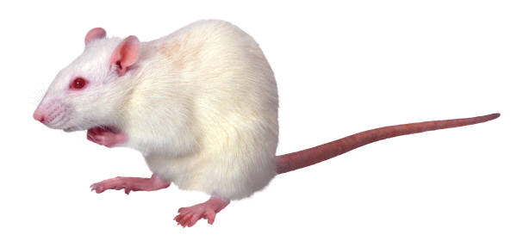
eats

Prey

eats
Prey

Hibernation
Sleep all winter:
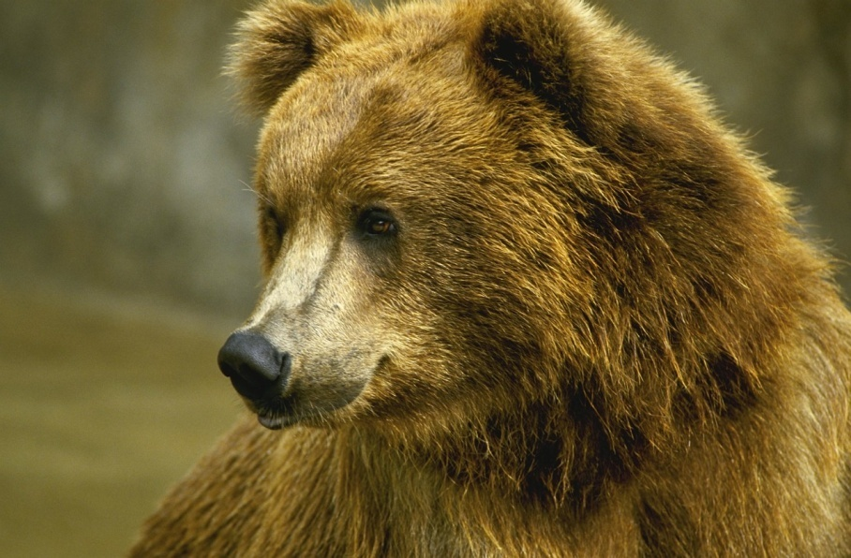&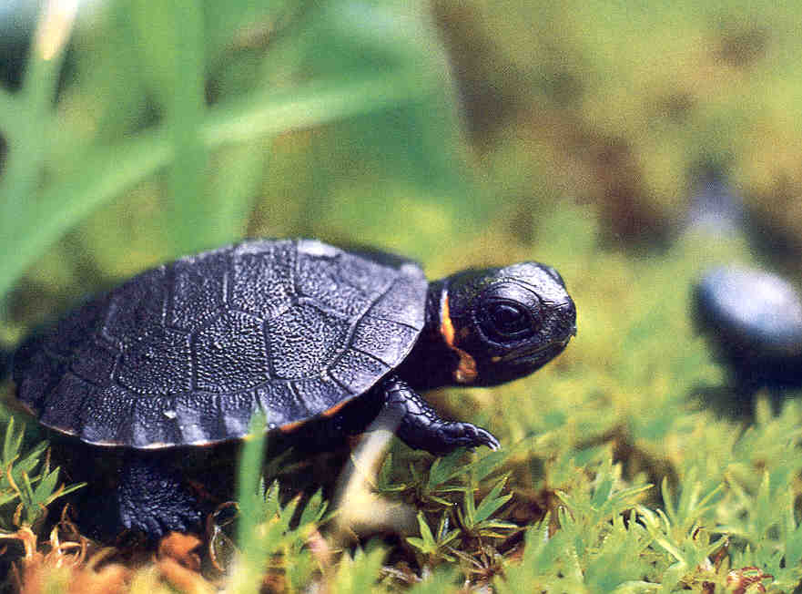

Habitat

& 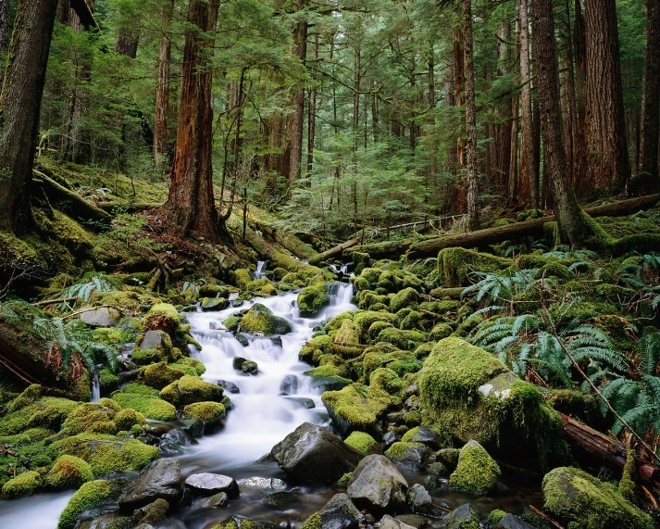

Habitat loss

→

Introduced species
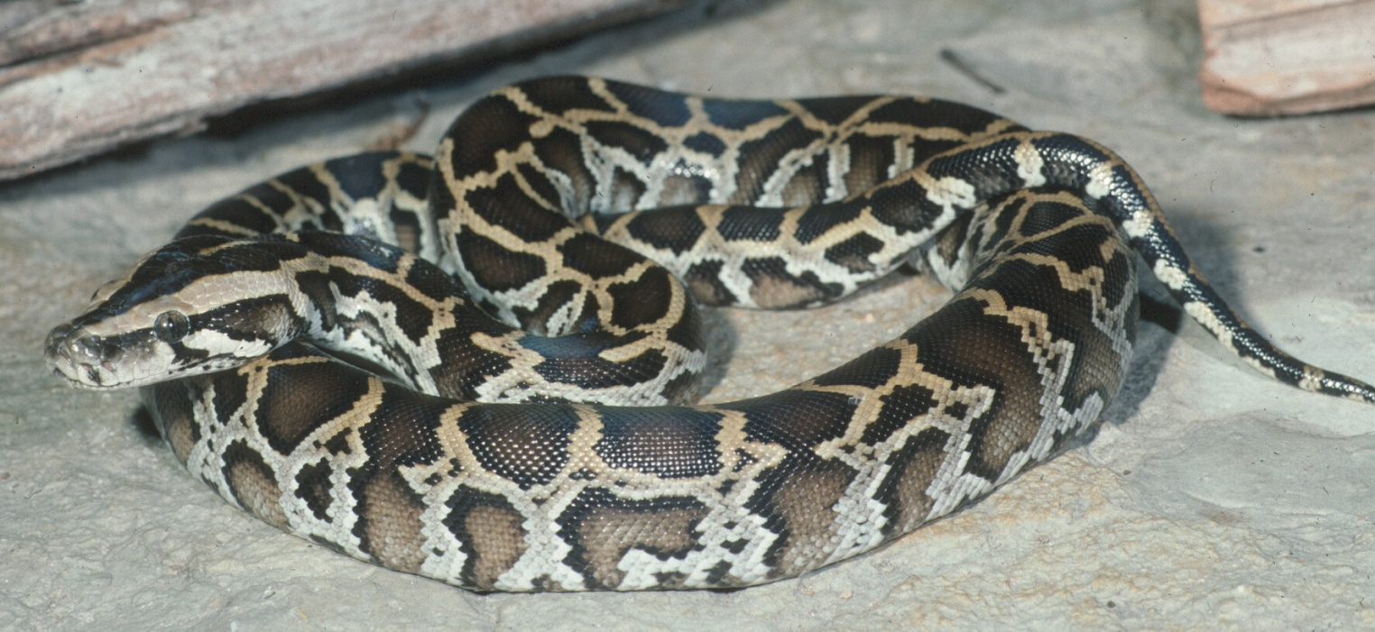
(Burmese python in Florida)

Over exploitation
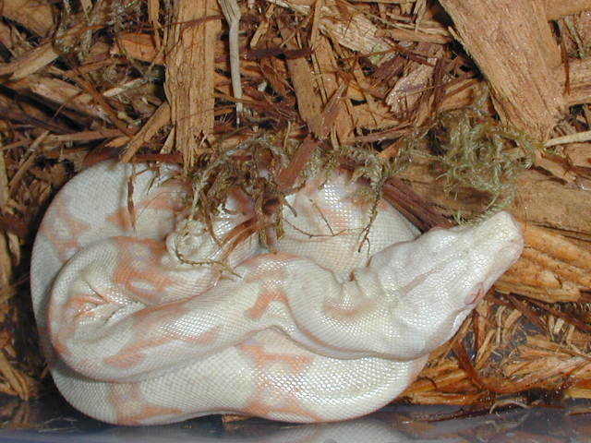  http://www.venomsupplies.com/exoticconference/boacomstrictor1.jpg | Pets food | 
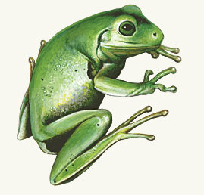  White’s treefrog  “This treefrog’s skin secretes chemicals that destroy bacteria and lower human blood pressure.” -National Zoological Park  http://nationalzoo.si.edu | medicine fashion |   http://images.jupiterimages.com/common/detail/99/13/22421399.jpg

Climate change

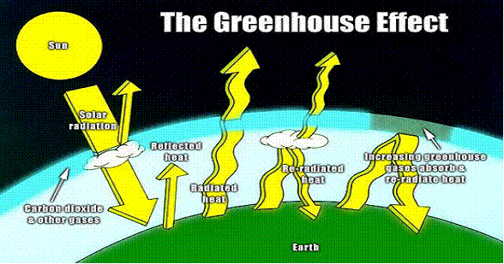
http://www.wyfsd.org/cms/uploads/images/image004.gif

UV-B radiation

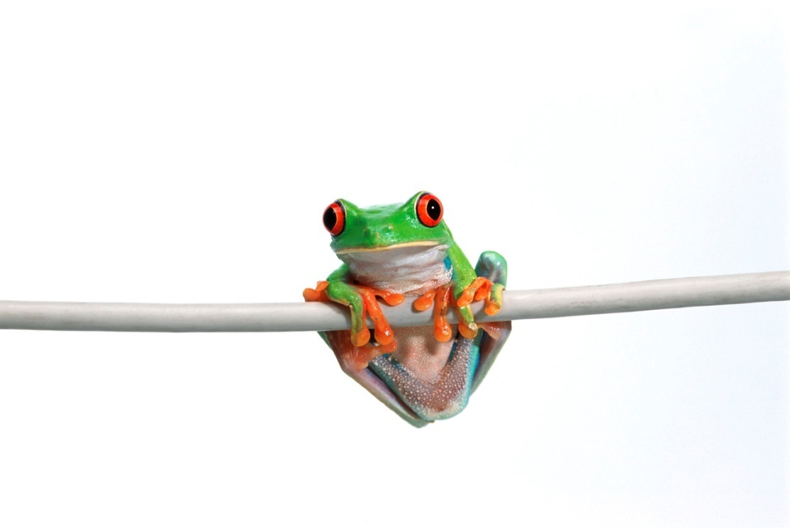
This one can’t
wear sunscreen!

Pollution

Disease

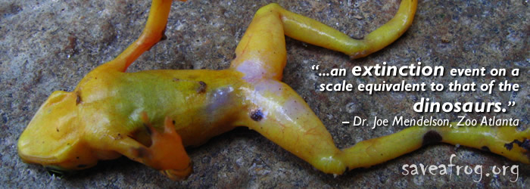

Monitor

To systematically keep track of something by collecting information on it.

Example: regular doctor visits help monitor your health
Ectotherm
(cold-blooded)

controlled by
Endotherm
(warm-blooded)

Controlled by

